18.75: a) From Eq. (18.19),

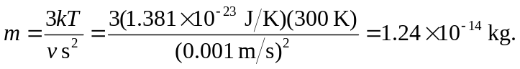

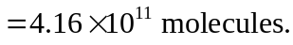

- 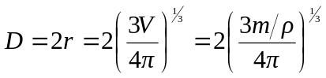
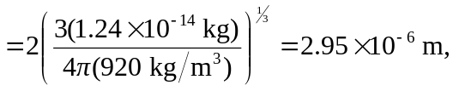
which is too small to see.

